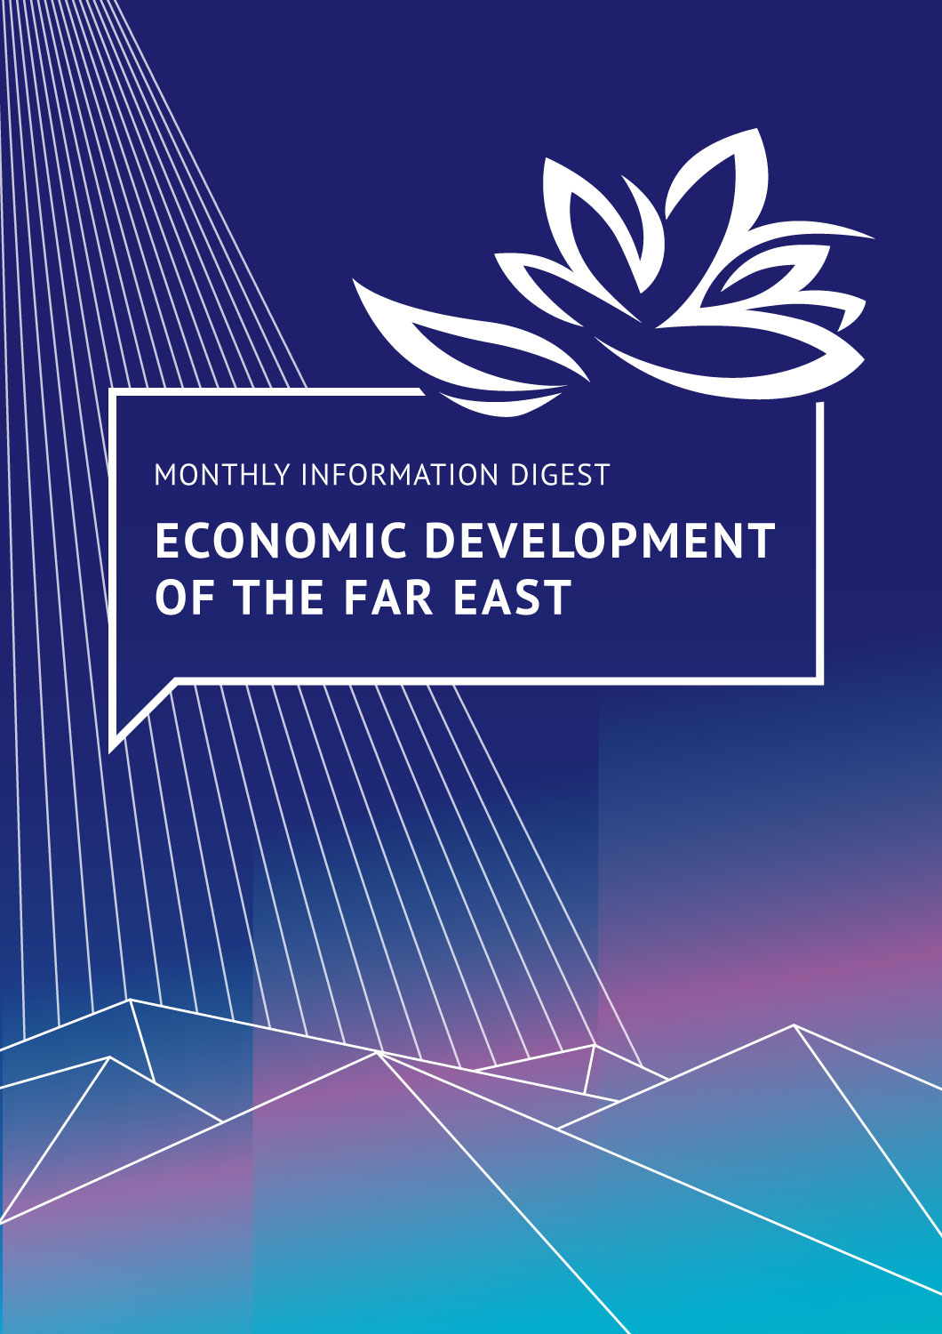
EASTERN ECONOMIC FORUM EVENTS
05/2022
30 May 2022, RIA Novosti
The ‘Far East Street’ setup starts on 1 June
The exhibition on the waterfront of Ajax Bay, which operated during the Eastern Economic Forum in 2021, will inaugurate its renewed format on 5 September 2022 and will be open to the public. Visitors will be able to explore the 11 pavilions at ‘Far East Street’, each being a symbol of the unique regions of the Far Eastern Federal District.
For the first time, the exhibition will feature two new pavilions, one of which will showcase Tourism.RF Corporation’s activity, with a particular focus on its projects in the Far East. The second pavilion, the House of the Tiger, will be dedicated to the 2nd International Tiger Forum, which will be held on 5 September – the opening day of EEF 2022. It will tell its visitors about Russia’s achievements in conserving this rare predator.
During EEF 2022 and the 2nd International Tiger Forum, the ‘Far East Street’ exhibition will be open to event visitors. From 9 to 11 September, the pavilions will be open to all residents and guests of Primorye Region.

ria.ru/20220530/vystavka-1791671238.html
23 May 2022, TASS
EEF 2022 plans to offer a rental mechanism for the Far East
This was announced by Alexander Levintal, Managing Director for the Far East at DOM.RF. The mechanism involves partial co-financing of rent by the region and could become a successful tool for the development of the Far East.
tass.ru/nedvizhimost/14697383

INTERNATIONAL ARCTIC FORUM EVENTS
30 May 2022, Interfax
Russian-Chinese cooperation discussed under the Think Arctic project
This project is part of Russia’s 2021–2023 chairmanship in the Arctic Council and is being implemented with the help of the Roscongress Foundation. According to Nikolay Korchunov, Chair of the Senior Arctic Officials, Ambassador-at-large of the Ministry of Foreign Affairs of the Russian Federation, Russia is open to cooperation with all states that take a constructive approach to high-latitude interaction. In his words, the main areas of Russian-Chinese cooperation in the Arctic region could be energy, including carbon-free energy, as well as projects to jointly develop the Northern Sea Route and the associated coastal infrastructure.
interfax.ru/events/news/843587
25 May 2022, TASS
Russia sums up the first year of its Chairmanship in the Arctic Council
During this time, 36 events were held on important issues on the Arctic agenda. The business programme for the St. Petersburg International Economic Forum 2022 will include the 'Arctic: Territory of Dialogue' forum, which will focus on responsible management for the sustainable development of the high-latitude regions. These discussions will present new solutions on key issues in the development of Russia’s Arctic territories, among them improving the quality of life of the region’s residents; developing the Northern Sea Route and infrastructure; climate change, and environmental protection.
tass.ru/novosti-partnerov/14725119
23 May 2022, Sekret Firmy
Participants in the ‘Arctic: Territory of Development’ conference in Yakutsk discussed integrated development of Arctic cities
The conference on ensuring a comfortable urban environment called 'Arctic: Territory of Development' was held on 22–25 May. Its main topic was the integrated development of cities in the North. The event addressed the development of master plans for communities in the Arctic zone, implementation of the 'Arctic Hectare' programme, and the renovation of housing and service economies. The conference was held as part of the major events under the Russia’s chairmanship in the Arctic Council in 2021–2023.
secretmag.ru/news/v-rossii-zadumalis-o-kompleksnom-razvitii-arkticheskikh-gorodov-23-05-2022.htm
18 May 2022, TASS
Teriberka festival guests will taste Arctic cuisine
More than 25 representatives of Murmansk Region’s restaurant business in the will take part in the 7th Arctic Festival Teriberka to be held in the village of the same name on the shores of the Barents Sea on 16–17 July. Restaurateurs will offer guests of the festival the best dishes on the Arctic menu in the ‘food in one hand’ format. In addition to promoting local produce and Arctic cuisine, the festival organizers will retain other traditional Teriberka ideas, such as revealing the unique tourist potential of small territories in Russia’s Arctic zone, and developing event tourism in the region.
tass.ru/obschestvo/14657403

STATE POLICY IN THE FAR EAST AND ARCTIC
23 May 2022, Izvestia
Vladimir Putin gave instructions at the Arctic development meeting
Vladimir Putin instructed the Russian Government to ensure social infrastructure for Arctic residents. In addition, the President gave an order to determine the timing and scope of deliveries by icebreakers along the Northern Sea Route. Mr. Putin also gave orders to amend legislation in favour of Rosatom State Corporation to carry out centralized management of the Northern Sea Route and organize navigation.
iz.ru/1338858/2022-05-23/putin-dal-riad-poruchenii-po-razvitiiu-arktiki

23 May 2022, Interfax
Russian Government will set additional support measures for investment projects in the Arctic
By 15 June this year, the Russian government will determine the list of projects for additional support measures. They may be secured, inter alia, from the federal budget and the National Wealth Fund, including the ‘project finance factory’ mechanism set by the state development corporation VEB.RF.
interfax.ru/russia/842447

ECONOMY OF THE FAR EAST AND ARCTIC
24 May 2022, TASS
Rostec will supply 21 Russian-made helicopters to a Far Eastern airline
Russian Helicopters Holding of Rostec State Corporation and Aurora (Far Eastern airline), signed an agreement to supply ten Mi-171A2 and eleven Mi-171A3 helicopters in the period between 2023 and 2026. The helicopters will be used for socially important transportation in the region.
tass.ru/ekonomika/14708035
23 May 2022, Kommersant
Primorye Territory government plans to purchase a hydrofoil for passenger transportation
A hydrofoil is planned to be used for passenger transportation from Vladivostok to Bolshoi Kamen. The State Transport Leasing Company has already applied for budgetary funds to build the vessel, which is planned to be commissioned by 2025. It will cost RUB 850 million, of which RUB 723.3 million will come from the federal budget and RUB 126.64 million from the region.
kommersant.ru/doc/5358897
16 May 2022, Vedomosti
Aeroflot will reduce the cost of subsidized flights to the Far East by 25%
Aeroflot will cut fares on subsidized flights between Moscow and the Far East by 25% from 17 May to 30 June. Fares will be adjusted for such destinations as Vladivostok, Petropavlovsk-Kamchatsky, Khabarovsk, Yuzhno-Sakhalinsk, Magadan, and Yakutsk.
vedomosti.ru/society/news/2022/05/16/922261-aeroflot-reshil-snizit-stoimost-subsidirovannih
11 May 2022, RT
Yamal to allocate a subsidy to study permafrost
The Yamalo-Nenets Autonomous District will allocate RUB 59 million to equip an Earth glaciology laboratory. The Centre for Arctic Development will receive a corresponding subsidy from the regional budget. The laboratory is intended to ensure the geotechnical safety of design, construction and operation of capital facilities in the Far North.
russian.rt.com/nopolitics/news/1001549-region-laboratoriya-merzlota

NEW MECHANISMS FOR THE FAR EAST DEVELOPMENT: SUCCESS STORIES
24 May 2022, TASS
Russian Arctic regions to launch the Arctic Startup Expedition
Mikhail Pogodaev, Special Representative of the Russian Chairmanship in the Arctic Council for Indigenous Peoples and Regional Cooperation said the Arctic Startup Expedition programme will be launched in the subjects of the Russian Arctic zone by the end of 2022. The programme aims at teaching technology entrepreneurship, involving indigenous peoples in innovation ecosystems, and searching for startups to solve technological problems of corporations.
tass.ru/obschestvo/14707485

